**Visualizing Loops in DNAlandscapeR**

Gaffney Lab @ OMRF

1) Navigate to **dnalandscaper.aryeelab.org**

2) Your data is contained within an **AWS Bucket** called “omrf-gaffney”. Thus, data from your experiments are only visible when you **import** the bucket. The tracks that are pre-loaded are other publically available data tracks that may be useful for visualization comparison. Here’s a quick overview of how to import this data.

Navigate to the **Import** tab.

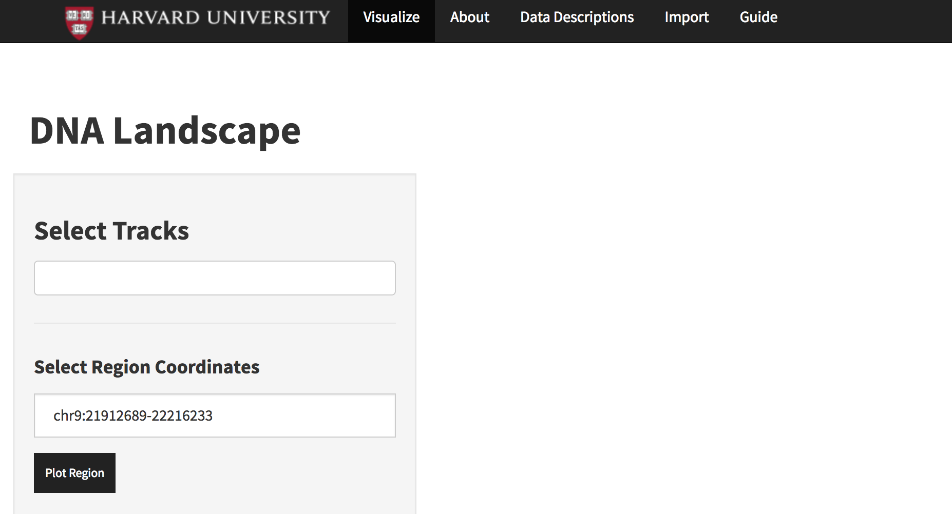

Scroll down to **Import AWS Bucket** and type “omrf-gaffney” then press **Import.**

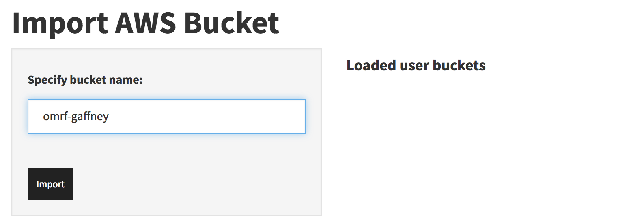

If you imported the bucket successfully, it should tell you on the table to the right—

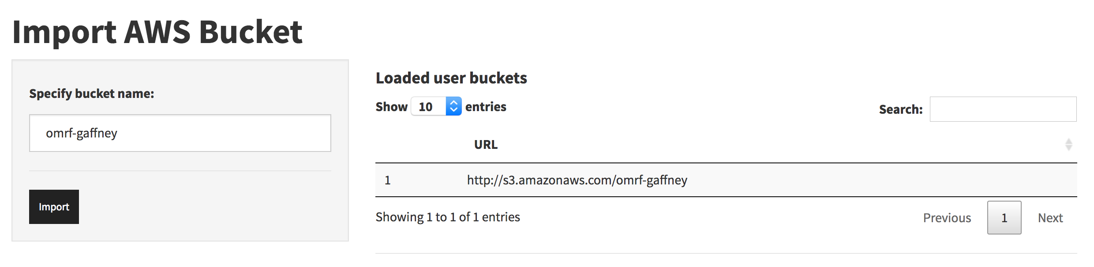

**Note:** If you previously selected a track in **Visualize** and it’s still selected, this import may mess up and crash the session. Best practice is to just import the bucket right away.

Now, navigate back to the **Visualize** tab. The samples that were specifically assigned to your bucket should be available now. You can start typing “HiChIP” to filter quickly for your tracks.

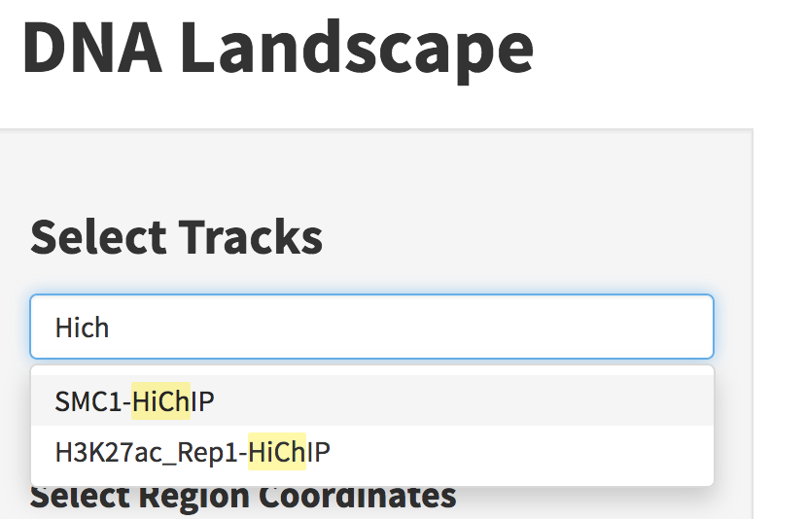

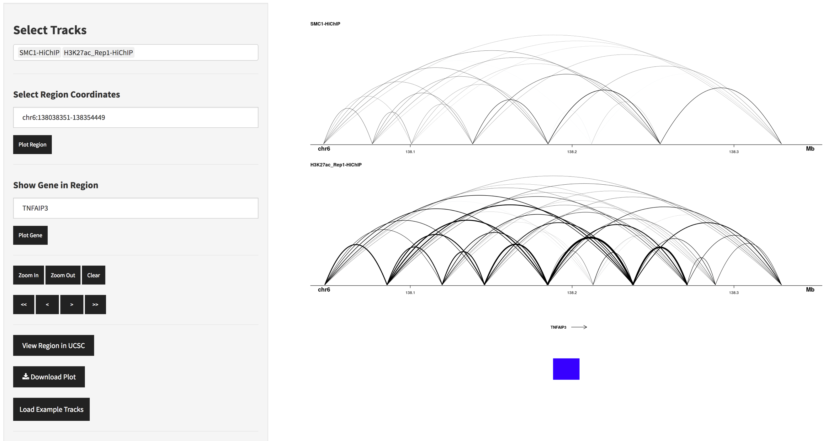

The browser should hopefully behave intuitively. However, I note that this HiChIP data is **BIG**. It may be slow to visualize loops for a particular region. Also, it can be noisy, as you can see here. There are filtering options if you scroll down, which may be appropriate here to filter by the number of reads shown per loop.

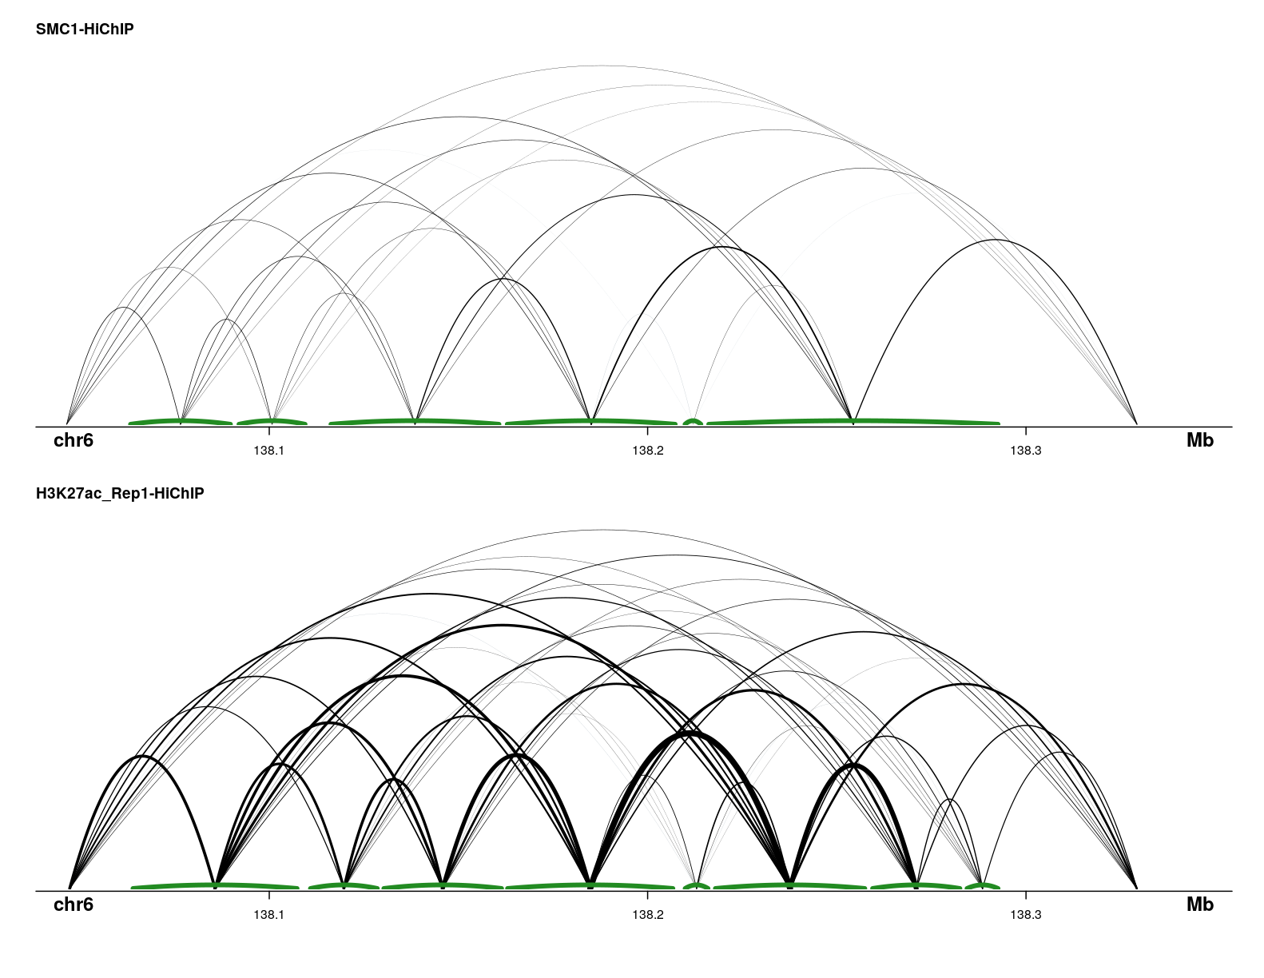

It may be nice to visualize the loop anchor width, like I show here. This plot suggests that I need to minimize the anchor widths in the preprocessing to really get a handle of what’s going on here.